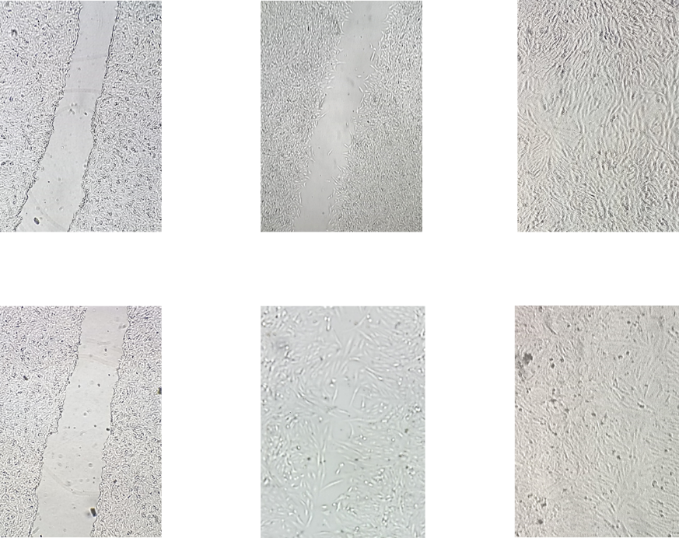

**0 hours 24 hours 48 hours**

**Control cells**

**EPR-treated cells**

**Figure S1**. EPR in-vitro wound healing activity detected at 0, 24, and 48 hours post-wound induction (40x magnification).